GRANDMASTER RICHARD “HUK” PLANAS MERCHANDISE ORDER FORM
Please print this order form and send to the following address-

Mr. Richard Planas
3412 N. Woodlawn Avenue, #3
Metairie, LA 70006
United States of America

Please make the check or money order payable to
Richard Planas, not Huk Planas.

Thank you.

NAME: ________________________________________________

STREET ADDRESS: _____________________________________

_______________________________________________________

CITY: _________________________________________________

STATE: _______________________________________________

ZIP CODE: _____________________________________________

TELEPHONE: __________________________________________

E-MAIL: _______________________________________________

DESCRIPTION PRICE QUANTITY TOTAL

Complete Collection - Volume 1 through 13 $520.00 X ___________ = $____________

Volume 1 - Beginning Basics $40.00 X ___________ = $____________
and Fundamentals of Kenpo
Volume 2 - Yellow Belt Techniques $40.00 X ___________ = $____________ and Family Groupings
Volume 3 - Short Form 1 and Long Form 1 $40.00 X ___________ = $____________

Volume 4 - Short Form 2 and Finger Set $40.00 X ___________ = $____________

Volume 5 - Long Form 2 $40.00 X ___________ = $____________

Volume 6 - Short Form 3 $40.00 X ___________ = $____________

Volume 7 - Long Form 3 $40.00 X ___________ = $____________

Volume 8 - Form 4: Part 1 $40.00 X ___________ = $____________

Volume 9 - Form 4: Part 2 $40.00 X ___________ = $____________

Volume 10 - Form 5: Part 1 $40.00 X ___________ = $____________

Volume 11 - Form 5: Part 2 $40.00 X ___________ = $____________

Volume 12 - Form 6: Part 1 $40.00 X ___________ = $____________

Volume 13 -Form 6: Part 2 $40.00 X ___________ = $____________

Two Man Set $40.00 X ___________ = $____________

Problem Techniques $40.00 X ___________ = $____________
SUBTOTAL $____________

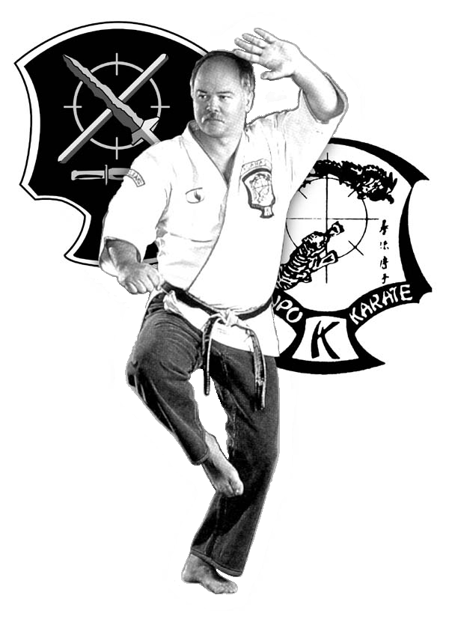
SHIPPING & HANDLING $6.00 FOR 1ST DVD, $1.50 FOR EACH ADDITIONAL $____________

TOTAL $____________

